Moving Charges & Magnetism

This set of notes covers the foundational concepts of magnetism as introduced in the lecture, focusing on the properties of current-produced fields and the necessary vector notations.

Overview of Magnetism
• Context: The study of magnetism is divided into two primary sections: Moving Charge and Magnetism (focusing on fields produced by electric currents) and Magnetism and Matter (focusing on materials and the Earth's magnetic field).
• Fundamental Principle: Magnetism is an inherent property associated with moving charges. While static charges produce only electric fields, moving charges (currents) produce magnetic fields.
• Magnetic Field (B⃗): This is a vector quantity denoted by the symbol B⃗. It represents the region around a current-carrying conductor where magnetic forces can be exerted on other magnets or moving charges.

Magnetic Properties of Current
• Experimental Basis: It is an experimental fact that whenever current passes through a wire or conductor, a magnetic field is generated around it.
• Observation: If a magnet (like a compass needle) is placed near a current-carrying wire, it experiences a torque/force, proving the existence of an associated magnetic property.
• Source of Field: In this chapter, the current (I) acting through a specific geometry (wire, loop, solenoid) is the source of the magnetic field.

Right-Hand Thumb Rule
The primary tool for finding the Direction of Magnetic Field is Right-Hand Thumb Rule.

For Straight Conductors:
• Point your right thumb in the direction of the current (I).
• The curl of your fingers represents the direction of the magnetic field lines (B) encircling the wire.

For Circular Loops (Alternative Method):
• Curl your fingers in the direction of the circular current flow.
• Your thumb will point in the direction of the magnetic field at the center of the loop.

Loop Thinking: For a loop, you can treat every small section as a straight wire to find the direction, but curling your fingers with the current is a faster "shortcut" for the center point.

Standard Notation
In 2D diagrams (like your exam paper), 3D directions are represented using specific symbols:
Symbol | Physical Meaning | Coordinate Interpretation
Cross (⊗) | Inward: Field points into the page/board. | Often represents the -z axis.
Dot (⊙) | Outward: Field points out of the page toward you. | Often represents the +z axis.
# Dot (⊙) tip of arrow, Cross (⊗) back of arrow

Current Element (I · dl⃗)
• Definition: While current (I) is a scalar quantity (it does not follow vector addition laws), a Current Element is a vector quantity.
• Mathematical Form: It is the product of current (I) and a small length element (dl⃗) of the wire.
• Direction: The direction of the current element vector is always the same as the direction of current flow in the wire.
• Why we use it: To calculate a vector magnetic field (B⃗), we require a vector source. The current element allows us to apply the Biot-Savart Law to find the field produced by a specific section of a wire.

High-Yield Revision Sheet (Must-Remember)
• The Source: Moving charges → Magnetic Field.
• The Rule: Right Hand Thumb Rule is the "Gold Standard" for direction.
• The Element: I·dl⃗ is a vector; direction = current direction.
• The Symbols:
⊗ = Into the page (Inward).
⊙ = Out of the page (Outward).

--------------------------------------------------------------------------------

Biot-Savart Law and Applications
The Biot-Savart Law is an experimental law that describes the magnetic field produced by a tiny current element. It is the magnetic equivalent of Coulomb's Law in electrostatics.
[ # magnitude formula se aur direction right hand se nikla h ye ek straight line wale ko chorke ]

• Vector Form:
dB⃗ = μ₀/(4π) × I(dl⃗ × r⃗)/r³
also -
dB⃗ = μ₀/(4π) × q(dv⃗ × r⃗)/r³
• This shows that dB⃗ is always perpendicular to both the current element and the position vector.

• Magnitude Form:
dB = μ₀I dl sin θ/(4πr²)
• θ is the angle between the current element dl⃗ and the position vector r⃗.
• Physical Meaning: The magnetic field is proportional to the current and the length of the element, and inversely proportional to the square of the distance (Inverse Square Law).

• Observation: The magnetic field is always zero at any point lying directly on the axis of the current flow. {∵ θ = 0˚ or 180˚, ∴ sinθ = 0}
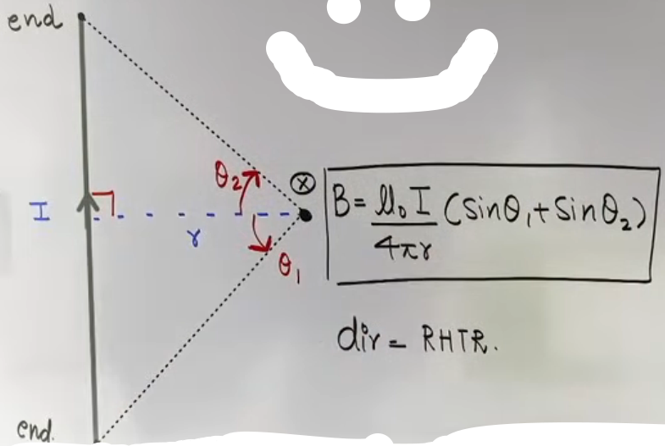
Application: Straight Current-Carrying Conductor
For a wire of finite length, the total field is found by integrating the Biot-Savart Law.

• General Formula:
B = μ₀I/(4πr) (sin θ₁ + sin θ₂)
- r: The perpendicular distance from the wire to the point.
- θ₁, θ₂: Angles subtended by the ends of the wire at the point, measured from the perpendicular line.

Special Cases of Straight Wires
Case | Geometry | Formula
Infinite Wire | Ends extend to infinity (θ₁, θ₂ = 90°). | B = μ₀I/(2πr)
Semi-Infinite Wire | One end is perpendicular; one is at infinity. | B = μ₀I/(4πr)
Off-Axis Point | Point is "below" or "above" the wire's length. | B = μ₀I/(4πr) (sin θ₂ - sin θ₁)
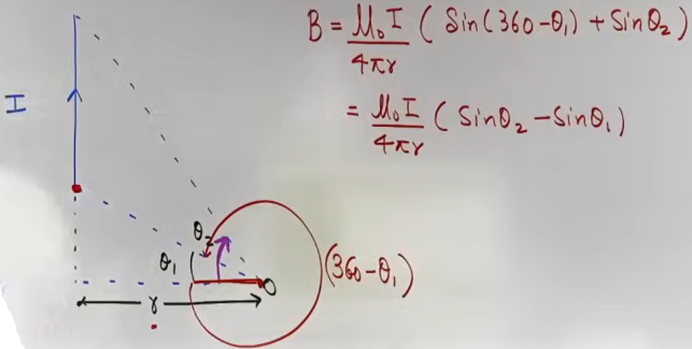
# ye dhyaan m rakhna h ki ek angle niche lena ha aur ek upar, isko solve karne k liye jitne wire chaihiye waha ek I aur ek -I ki wire same length ki likhta phir badi wire aur ulti choti wire k magnetic field ko minus kar diya.

Null point between two parallel infinite wire
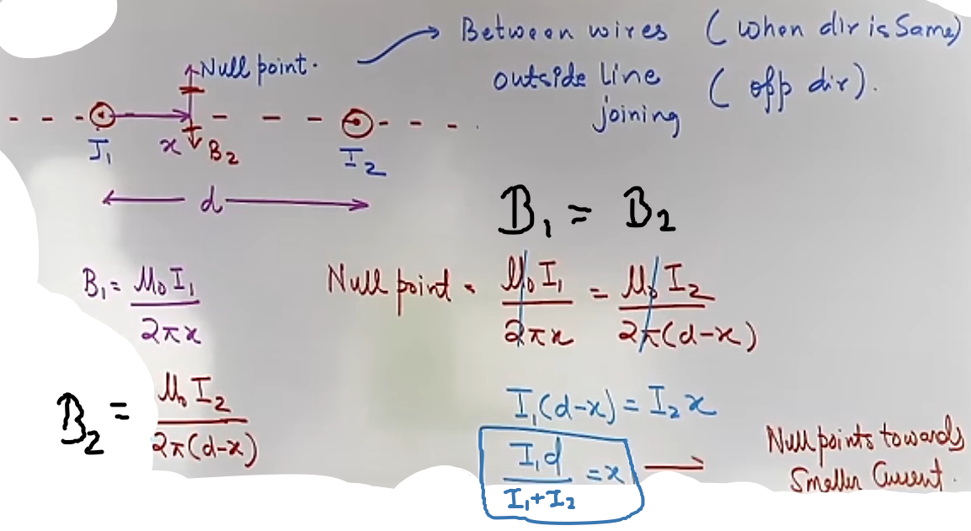
Application: Circular Arcs and Standard Shapes
The field at the center of a circular path is highly symmetric, making the calculation straightforward.

• General Formula for an Arc:
|B| = (μ₀I/2R) × (θ_degrees/360°)
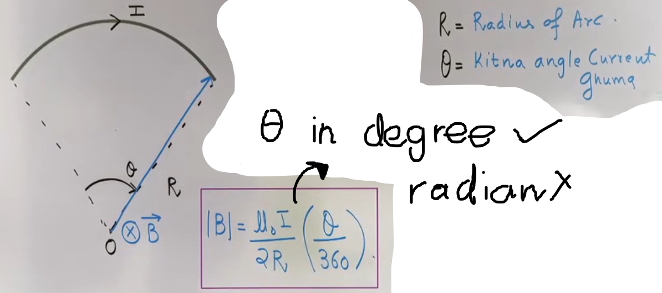
• Alternatively, using radians: B = μ₀I(θ_rad)/4πR.

Standard Circular Shapes
+----------------+-----------+------------------------------+
| Shape | Angle (θ) | Magnetic Field (B) at Center |
+----------------+-----------+------------------------------+
| Full Circle | 360° (2π) | B = μ₀I/(2R) |
| Semi-Circle | 180° (π) | B = μ₀I/(4R) |
| Quarter Circle | 90° (π/2) | B = μ₀I/(8R) |
+----------------+-----------+------------------------------+

Application: Current-Carrying Ring (Axial Point)
To find the field at a distance x from the center of a ring along its axis:
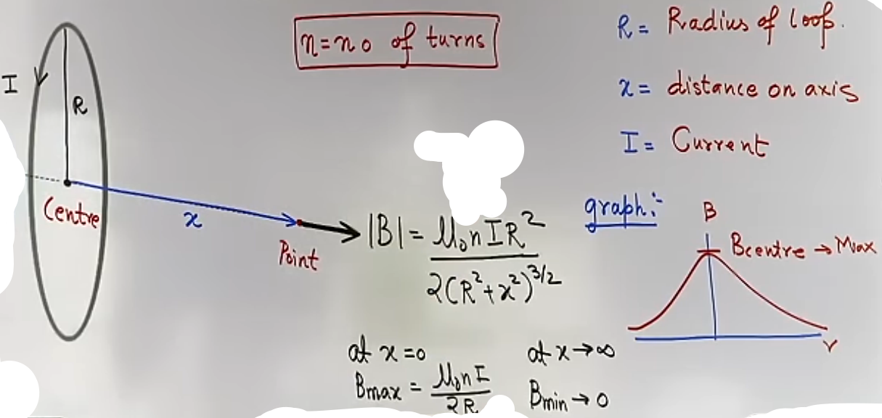
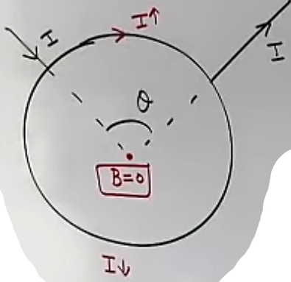
• Formula:
B_axis = nμ₀IR²/[2(R² + x²)^(3/2)]
• n: Number of turns in the coil.
• R: Radius of the ring.
• x: Distance from the center along the axis.
Magnetic field maximum at x = 0
Magnetic field minimum at x = infinity

kuch current uppar se jayega aur kuch neeche se aur magnetic field at centre hoga 0 no matter what the θ is

Problem-Solving Framework
Question Type | Identification Clues | Strategy | Common Mistakes
Segmented Wire | Wire consists of straight and curved parts. | Use superposition: B⃗_net = ΣB⃗_i. Check directions (⊗ vs ⊙). | Forgetting that field is zero for segments pointing at the target point.
Infinite Wire | "Very long" or "Infinite" wire. | Use B = μ₀I/(2πr). | Confusing 2πr (infinite) with 4πr (semi-infinite).
Moving Charges | Field produced by a single moving point charge. | Use B = (μ₀/4π) × q(v⃗ × r⃗)/r³. | Treating qv⃗ differently than I dl⃗. They are equivalent.

Common Mistakes and Traps
• The "Axis" Trap: Students often calculate a value for a point that lies on the extension of a straight wire. The field is zero there because θ = 0.
• Distance Error: In the straight wire formula, r must be the perpendicular distance. If given a slant distance, you must use trigonometry to find the perpendicular.
• Angle Direction: In the finite wire formula, θ₁ and θ₂ are measured in opposite directions from the perpendicular. If they are on the same side (off-axis), you must subtract them.

High-Yield Revision Sheet
• Biot-Savart: dB ∝ (sinθ)/r². No field on the axis of current.
• Straight Wire: μ₀I/(2πr) {Infinite}; μ₀I/(4πr) {Semi-Infinite}.
• Circular Loop: μ₀I/(2R) at center; μ₀IR²/[2(R²+x²)^(3/2)] on axis.
• Symmetry Tip: For any closed loop where current enters at one point and exits at another, the magnetic field at the center is zero if the wire is uniform.
• Direction Rule: Right-hand thumb = Current; Fingers curl = Magnetic Field.

--------------------------------------------------------------------------------

Ampere’s Circuital Law (ACL)

• Statement: The line integral of the magnetic field (B⃗) around any closed loop (called an Amperian Loop) is equal to μ₀ times the net current (I_enclosed) threading through the area enclosed by that loop.
• Mathematical Form:
∮ B⃗ · dl⃗ = μ₀ I_enclosed
• Key Distinctions: Line vs. Surface Integral: Unlike Gauss’s Law in electrostatics, which uses surface integrals (flux), ACL uses line integrals along the boundary of a loop.
• The Nature of B⃗: The magnetic field B⃗ at any point on the loop is the resultant field due to all currents (both inside and outside the loop).
• The Nature of I_enclosed: Only the currents passing inside the loop contribute to the total line integral value.

Sign Convention (Right-Hand Thumb Rule)
To determine which currents are positive or negative in the ACL equation:

Define Loop Direction: Choose a direction to traverse your Amperian loop (clockwise or counter-clockwise).
Curl Rule: Curl the fingers of your right hand in the direction of the loop.
Thumb Direction: Your thumb points in the direction of positive current.
• Example: If your thumb points up, currents going "up" are +I, and currents going "down" are -I.

ACL Applications (Standard Geometries)

A. Infinite Straight Wire
• Geometry: A long wire carrying current I. We choose a circular Amperian loop of radius r.
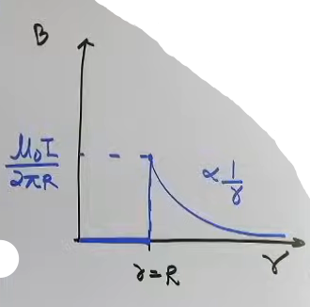
• Derivation Snippet: Since B⃗ is constant and parallel to dl⃗ along the circle, ∮B·dl = B(2πr) = μ₀I. # B is constant !
• Formula: B = μ₀I/(2πr)
• Observation: The field varies as B ∝ 1/r.

B. Thin Hollow Cylinder (Pipe)

• Inside (r < R): Since the cylinder is hollow and the current flows only on the surface, I_enclosed = 0. Therefore, B_in = 0.
• Outside (r > R): The loop encloses the entire current I. It behaves like a thin wire: B_out = μ₀I/(2πr).
• Graph: B is zero until r=R, then drops as 1/r.

C. Solid Current-Carrying Cylinder (Uniform Current Density)
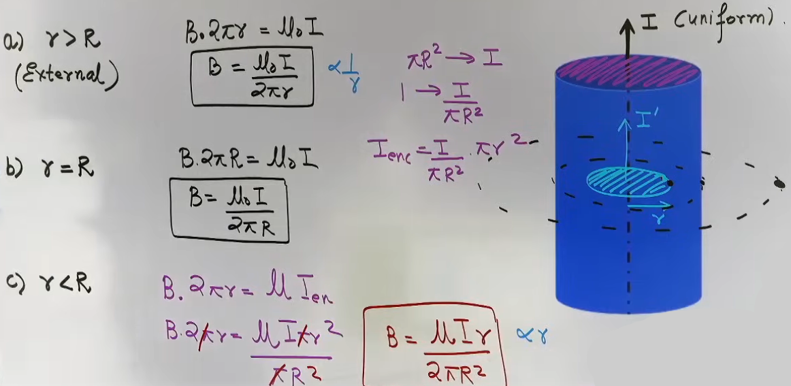
Current I is distributed uniformly across the cross-section of radius R.
• Outside (r > R): Encloses total current I. B_out = μ₀I/(2πr).
• At Surface (r = R): B_surface = μ₀I/(2πR).
• Inside (r < R): Only a fraction of the current is enclosed: I_enclosed = I · (πr²)/(πR²). # I enclosed unitary method se nikalenge
- Formula: B_in = μIr/(2πR²) # μ₀ ki jagah μ use karenge, medium wire hi h
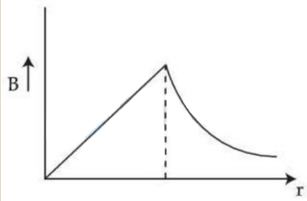
• Graph: B increases linearly (B ∝ r) inside and decreases as 1/r outside.

# graph p direct question aaya h !!

D. Thick Hollow Cylinder (Coaxial/Pipe with Thickness)
A cylinder with inner radius a and outer radius b.
• Region 1 (r < a): No enclosed current. B = 0.
• Region 2 (a < r < b): Enclosed current is found using the area ratio:
I_encl = I (r² - a²)/(b² - a²).
Formula: B = (μ₀I/2πr) × (r² - a²)/(b² - a²)
• Region 3 (r > b): Encloses total current I. B = μ₀I/(2πr).

E. Variable Current Density (J varies with r)
When current density J is a function of radius (e.g., J = kr²), you cannot use simple area ratios.
• Approach: Integrate dI = J·dA where dA = 2πr dr.
• Example (J = kr²):
• I_encl = ₀∫ˣ (kr²)(2πr) dr = πkx⁴/2.
• Applying ACL: B(2πx) = μ₀(πkx⁴/2) ⇒ B_in = μ₀kx³/4.

Intuition and Problem-Solving Framework
Why Choose a Circular Amperian Loop?
- We choose circles because of symmetry:
Constant Magnitude: At a fixed distance r, B is constant and can be taken out of the integral.
Angle Alignment: The angle between B⃗ and dl⃗ is 0° or 180°, so cos θ = 1 or -1, making the dot product easy to calculate.
Known Length: The integral ∮ dl simply becomes the circumference (2πr).

JEE Advanced Insights
• Medium Permeability: If the point is inside a medium (not vacuum), replace μ₀ with μ (medium's permeability).
• Random Loops: ACL is technically true for any loop, but it is only useful for symmetric ones where B is constant along the path.
• Current Density (J): In Advanced problems, J is often the starting point. Always remember J = dI/dA.

High-Yield Revision Sheet
• General Formula: B(2πr) = μ₀ I_encl.
• Solid Cylinder: B ∝ r (Inside); B ∝ 1/r (Outside).
• Hollow Cylinder: B = 0 (Inside).
• Sign Rule: Thumb = Positive Current; Fingers = Loop direction.
• Advanced Tip: For variable J, I = ∫J·2πr dr. Limits define whether you are finding internal or total current.

--------------------------------------------------------------------------------

Solenoids and Toroids

• Definition: A solenoid is a wire coiled such that its radius (R) is significantly smaller than its length (L) (R <<< L).
• Ideal (Infinite) Solenoid: A solenoid is considered "ideal" when its length is very large compared to its radius.
• Direction: Use the Right-Hand Thumb Rule for loops; curl your fingers in the direction of the current, and your thumb points to the North pole of the solenoid.

• Magnetic Field Distribution:
- Internal Region: The magnetic field is uniform and parallel to the axis of the solenoid.
- Lateral External Region: The magnetic field is approximately zero just outside the lateral sides of an ideal solenoid.
- End Points: As you move toward the ends of a solenoid, the field lines begin to spread out, and the intensity decreases. # The MF just outside one end is half of what is inside.

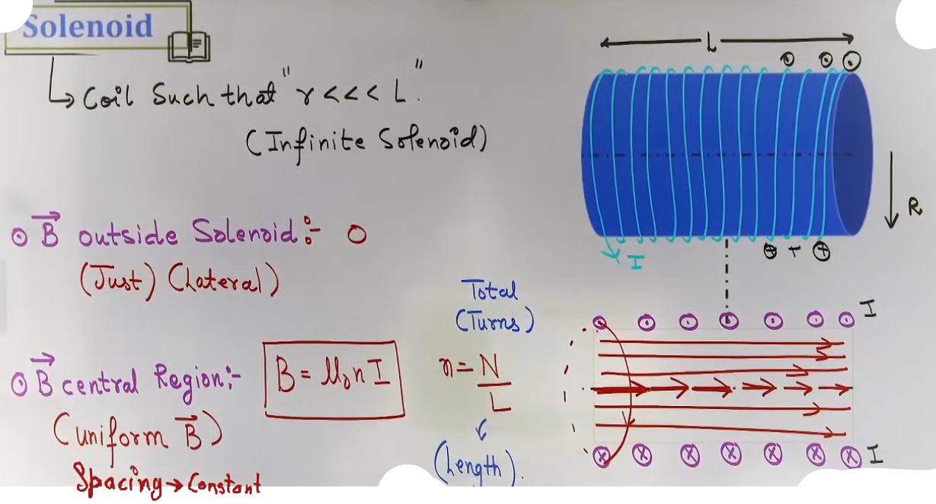
Intuition and Conceptual Understanding
• Visualizing the Field: Inside the solenoid, the field lines are straight and equally spaced, indicating a uniform field. Outside, the lines form large closed loops, but for an ideal solenoid, the external field is so weak compared to the internal field that it is treated as zero for calculation purposes.
• The "Endless" Solenoid: A Toroid is intuitively a solenoid bent into a circle to join its ends. Because it has no ends, it acts as a "magnet with no poles".

Formula Sheet: Solenoids
Solenoid Type | Point of Interest | Formula | Key Notes
Infinite | Center / Internal | B = μ₀nI | n = N/L (turns per unit length).
Infinite | At the Ends | B_end = μ₀ n I/2 | The field at the edge is exactly half the central value.
Finite | Axial Point | B = μ₀n(I/2) x  (sin θ₁ + sin θ₂) | θ₁, θ₂ are angles from the perpendicular to the ends.
# last wala vaise syllabus m nahi h shayad :)

The Toroid { μ₀NI/(2πr) }
• Definition: A toroid is a hollow circular ring on which a large number of turns of a wire are closely wound.
“Magnet with no poles.”

• Magnetic Field Zones:
- Interior (r < a): In the empty space enclosed by the toroid,the field is zero.
• Core (a < r < b): The magnetic field exists within the core of the toroid.
• Exterior (r > b): Outside the toroid, the net enclosed current is zero (for every "in" current, there is an "out" current), so the field is zero.
• Non-Uniformity: Unlike a solenoid, the field inside a toroid is not uniform; it depends on the distance (r) from the center of the toroid (B ∝ 1/r).

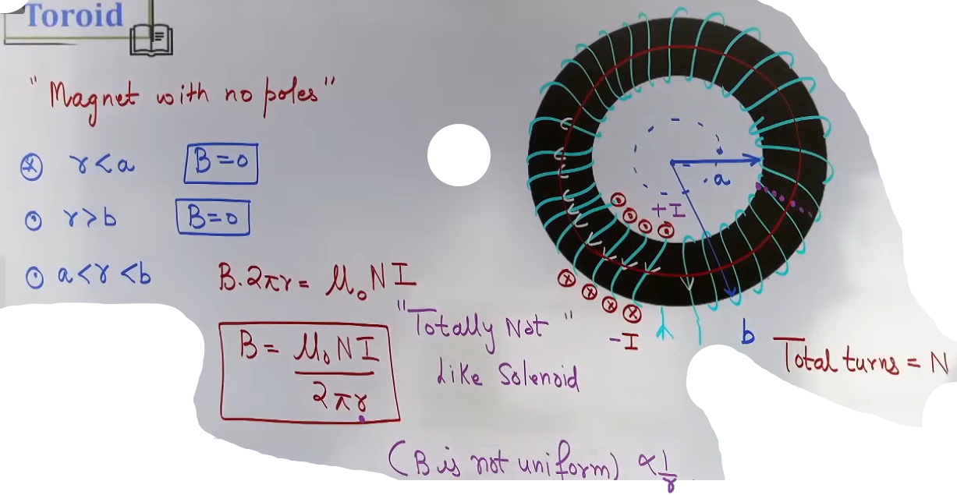
Formula Sheet: Toroids
+----------------+----------------+--------------------------------------------+
| Property | Formula | Details |
+----------------+----------------+--------------------------------------------+
| Magnetic Field | B = μ₀NI/(2πr) | N is the total number of turns. |
| Center Field | B = 0 | No current is enclosed in the central hole.|
| External Field | B = 0 | Total enclosed current is zero. |
+----------------+----------------+--------------------------------------------+
JEE Advanced: Toroid Flux
In advanced problems, you may be asked to calculate the magnetic flux (Φ) through a toroid with a rectangular cross-section.

• Approach: Because the magnetic field (B) is non-uniform (B ∝ 1/r), you must integrate the flux through a small strip.
• Setup: Take a strip of thickness dr at distance r with height h.
• Flux Formula:
Φ = ₐ∫ᵇ B·(h dr) = μ₀NIh/(2π) ln(b/a)
• a = Inner radius, b = Outer radius, h = Height of the rectangle.
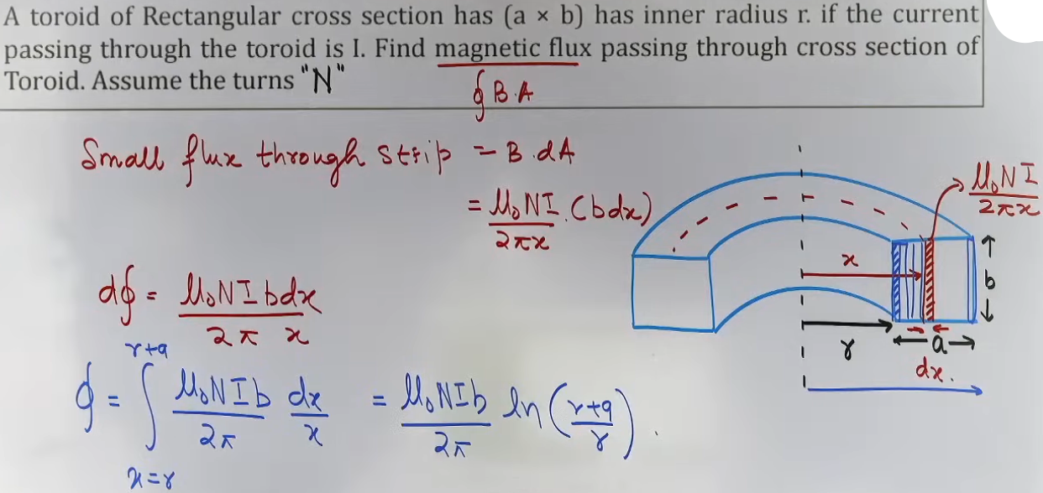
Problem-Solving Framework
Question Type | Identification Clues | Approach / Strategy
Solenoid Interior | "Long solenoid" or "Ideal solenoid." | Use B = μ₀nI. Check if n is given or needs to be calculated (N/L).
Solenoid Edge | Field at the "mouth" or "end." | Calculate B_center and divide by 2.
Coaxial Solenoids | Two solenoids one inside the other. | Use superposition: B⃗_net = B⃗₁ ± B⃗₂ based on current directions.
Toroid Core | Finding B at a specific radius r. | Use B = μ₀NI/(2πr).

High-Yield Revision Sheet
Must Remember:
• Solenoid (Central): B = μ₀nI.
• Solenoid (End): B = ½ μ₀nI.
• Toroid (Internal): B = μ₀NI/(2πr).
• Toroid (External/Central Hole): B = 0.

Frequently Tested Patterns:
• Comparing field strengths at the center vs. the end of a long solenoid.
• Finding flux through a toroid requiring integration.

--------------------------------------------------------------------------------

Motion of Charges in Magnetic Fields

These notes provide a comprehensive study of how point charges behave when subjected to magnetic and electric fields, covering all theoretical and numerical aspects for JEE Main and Advanced.

Magnetic Force on a Charge (F⃗ₘ)
• Definition: When a charge q moves with velocity v⃗ in a magnetic field B⃗, it experiences a magnetic force.
• Mathematical Expression:
F⃗ₘ = q(v⃗ × B⃗)
• Magnitude: Fₘ = qvB sin θ, where θ is the angle between v⃗ and B⃗.
• Direction (Right-Hand Rule):
- Point fingers of the right hand along v⃗, curl them toward B⃗. The thumb points in the direction of the force for a positive charge.
- Crucial Note: For a negative charge (like an electron), the force direction is opposite to the result of (v⃗ × B⃗).

Intuition and Conceptual Understanding
• Work and Energy: Since F⃗ₘ is always perpendicular to v⃗ (F⃗ₘ ⟂ v⃗), the work done by the magnetic force is always zero.
• Speed vs. Velocity: Magnetic force cannot change the speed or kinetic energy of a particle; it can only change its direction of motion.

Zero Force Conditions
A charge will experience no magnetic force (Fₘ = 0) under the following conditions:
• Particle at Rest: If v = 0, the magnetic field cannot move the charge.
• Parallel Motion: If v⃗ ∥ B⃗ (θ = 0°), the path remains a straight line.
• Anti-parallel Motion: If v⃗ is opposite to B⃗ (θ = 180°), the path remains a straight line.

Trajectories in a Uniform Magnetic Field
A. Circular Trajectory (Case: v⃗ ⟂ B⃗)
When a charge enters a magnetic field perpendicularly (θ = 90°), the magnetic force acts as a centripetal force, compelling the particle into a circular path.

Circular Motion Parameters:
Parameter | Formula | Key Insight | IDK
Radius (R) | R = mv/(qB) | R is proportional to momentum (p). | {m(v²)/r = qvB}
Angular Velocity (ω) | ω = qB/m | Depends only on specific charge (q/m) and B. | {ω = v/r}
Time Period (T) | T = 2πm/(qB) | Crucial: T is independent of speed (v) and radius (R). | {T = 2(pi)/ω}
Frequency (f) | f = qB/(2πm) | Often called the Cyclotron Frequency. | {f = 1/T}
Radius  (using K.E.) | R = √(2mK)/(qB) | Useful when the accelerating potential (V) is given.

B. Helical Trajectory (Case: Arbitrary Angle θ)
If v⃗ is at an angle θ (other than 0°, 90°, 180°), the velocity is resolved into two components:
• Parallel Component (v∥ = v cos θ): Maintains a straight-line motion along the field.
• Perpendicular Component (v⊥ = v sin θ): Provides the circular motion.

Helical Parameters:
• Radius of Helix: R = mv sin θ/(qB).
• Pitch of Helix (P): The linear distance moved by the particle in one complete rotation.
P = v∥ × T = (v cos θ) 2πm/(qB)
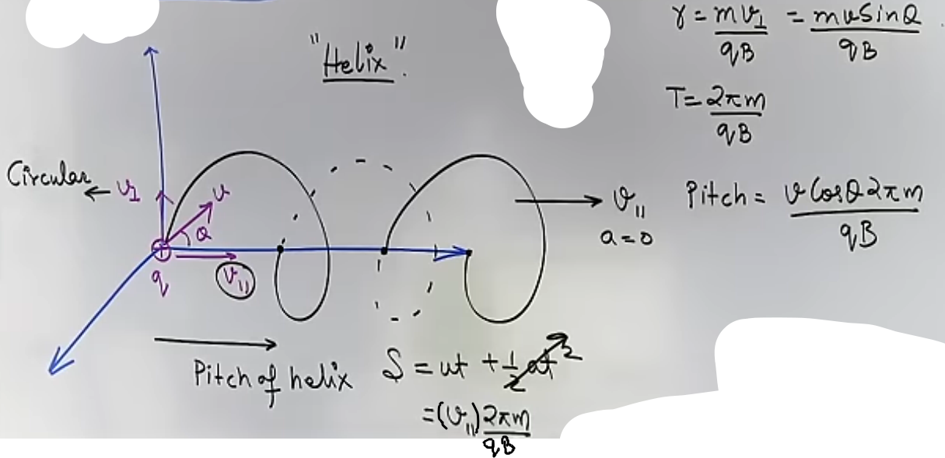
Combined Fields and Applications

Lorentz Force
When both electric (E⃗) and magnetic (B⃗) fields are present, the total force on a charge is the vector sum:
F⃗_net = qE⃗ + q(v⃗ × B⃗).

Velocity Selector { not in syllabus }
A device using crossed fields (perpendicular E⃗ and B⃗) to filter particles of a specific velocity.
• Condition: Magnetic force balances electric force (qE = qvB).
• Selected Velocity: v = E/B.
• Particles with this specific velocity move straight (undeflected).

Cyclotron { not in syllabus }
A particle accelerator that uses a high-frequency alternating voltage and a magnetic field to accelerate heavy positive charges.
• Working Principle: Magnetic field keeps particles in a circular path; electric field between "Dees" accelerates them twice per cycle.
• Maximum Kinetic Energy: Kₘₐₓ = q²B²R²/(2m).
• Limitations:
• Cannot accelerate neutrons (no charge).
• Cannot accelerate electrons (relativistic mass increase m = m₀/√(1 - v²/c²) causes them to fall out of step with the oscillating field).

Deflection in Limited Fields
When a charge passes through a magnetic field of limited width (d):
• Angle of Deflection (θ): Found using sin θ = d/R, where R is the radius of the circular arc.
• Vertical Shift (y): The displacement in the direction perpendicular to original motion.
y = R(1 - cos θ).
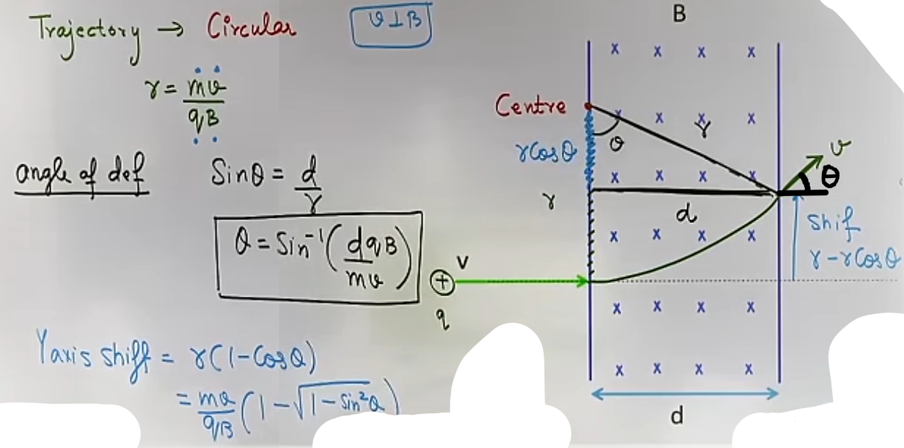
Problem-Solving Framework
Question Type | Identification Clues | Approach / Strategy
Path Identification | Angle θ between v⃗ and B⃗. | 0/180° → Straight;  90° → Circle; Other → Helix.
Comparison of Charges | Protons, Alphas, Electrons in same B. | Use R = mv/(qB) or R ∝ √(mK)/q. Compare m/q ratios.
Combined Fields | E⃗ and B⃗ given. | Check if forces balance (v = E/B). If not, use vector addition.
Time Spent in Field | Particle enters and exits at an angle. | t = θ_arc/ω = mθ_rad/(qB).
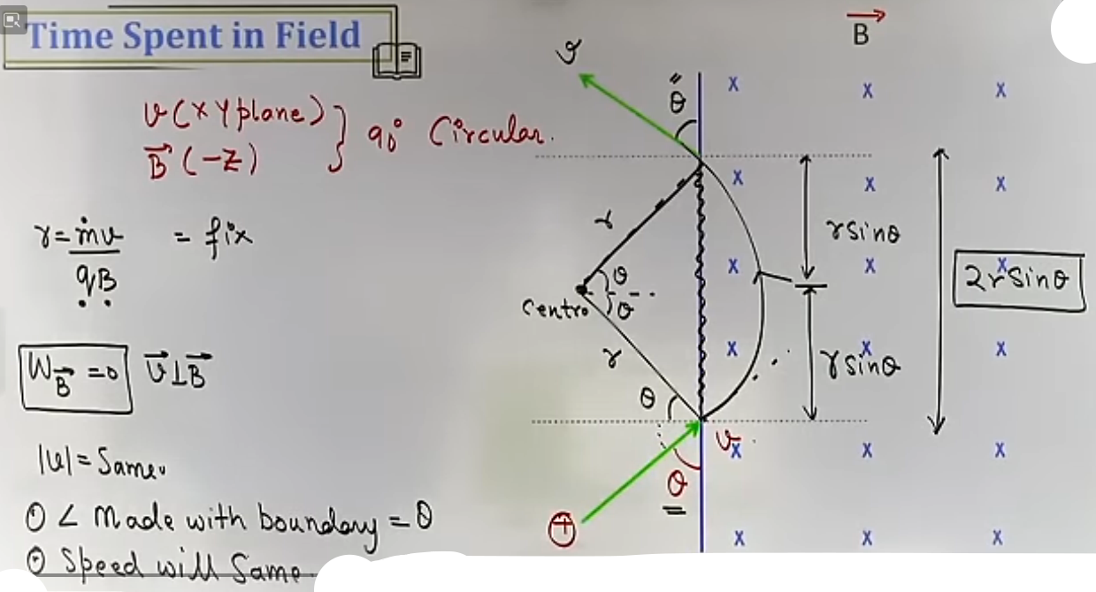
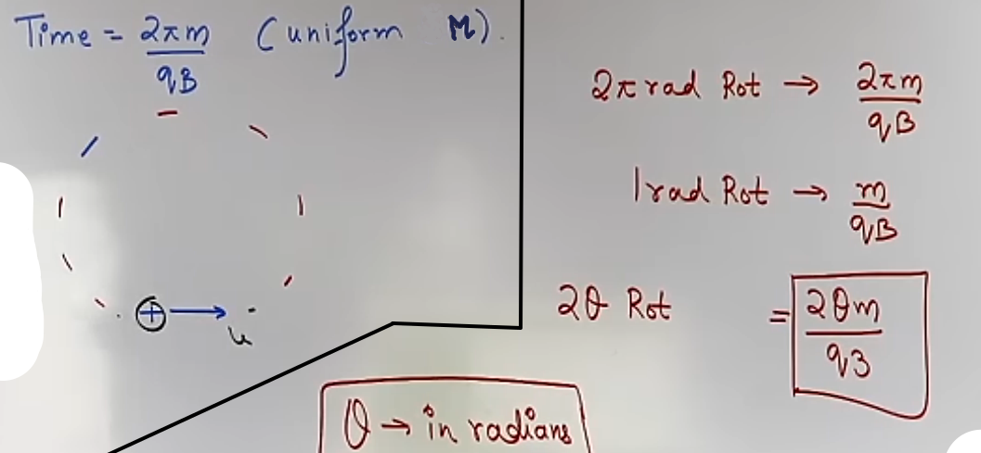
High-Yield Revision Sheet (Must Remember)
• Basic Force: F⃗ = q(v⃗ × B⃗). If v⃗ ⟂ B⃗, F = qvB.
• Radius: R = mv/(qB) = p/(qB) = √(2mK)/(qB).
• Time Period: T = 2πm/(qB) (Independent of velocity!).
• Pitch: P = (v cos θ) T.
• Velocity Selector: v = E/B.
• Cyclotron Limit: Doesn't work for electrons due to relativistic mass increase.
• Angular Deflection: sin α = d/R.

--------------------------------------------------------------------------------

Force on Conductors in a Magnetic Field

• Magnetic Force on a Current-Carrying Wire: When a wire carrying current I is placed in an external magnetic field B⃗, the moving electrons inside the wire experience a magnetic force. The sum of these individual forces results in a macroscopic force on the conductor.
• Vector Formula:
F⃗ = I(L⃗ × B⃗)
• Magnitude: F = BIL sin θ, where θ is the angle between the length vector L⃗ and the magnetic field B⃗.
• Assumptions/Conditions:
- Uniform Field: The standard formula I(L⃗ × B⃗) is strictly valid for straight wires in a uniform magnetic field.
- Direction of L⃗: The length vector L⃗ always points in the same direction as the current flow.
• Special Cases:
- Parallel/Anti-parallel (θ = 0° or 180°): The magnetic force is zero.
- Perpendicular (θ = 90°): The force is maximum: F = BIL.
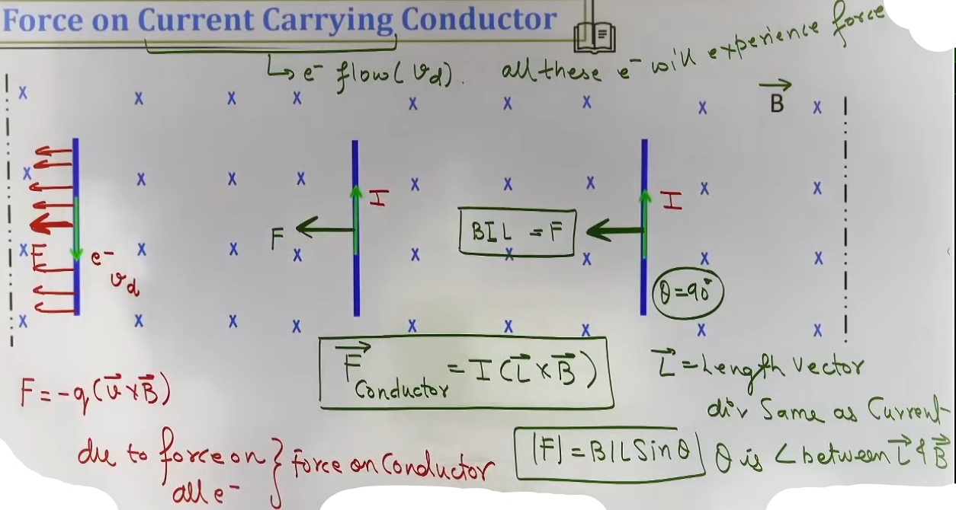
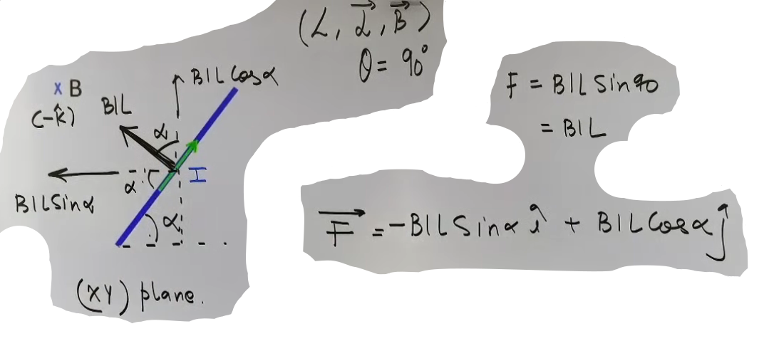
Intuition and Conceptual Understanding
• Mental Model: Think of the current-carrying wire as a "stream of moving charges." Just as a single charge q experiences q(v⃗ × B⃗), the wire experiences a force because it contains a specific number of these moving charges per unit length.
• Visualizing the Cross Product: Use the Right-Hand Rule. Point your fingers along the current (I) and curl them toward the magnetic field (B). Your thumb points to the direction of the force.

Effective Length (L_eff)
• Definition: For a "curved or non-straight wire" in a "uniform magnetic field", you do not need to integrate over every segment. Instead, replace the complex wire with a straight vector connecting the starting point and the ending point.
• Mathematical Interpretation: L⃗_eff = ∫dL⃗, which is simply the displacement vector from the initial to the final point of the wire.
• Force on a Closed Loop: In a uniform magnetic field, the starting and ending points of a closed loop are identical, meaning L⃗ₑff = 0. Consequently, the net magnetic force on any closed loop in a uniform field is always zero.

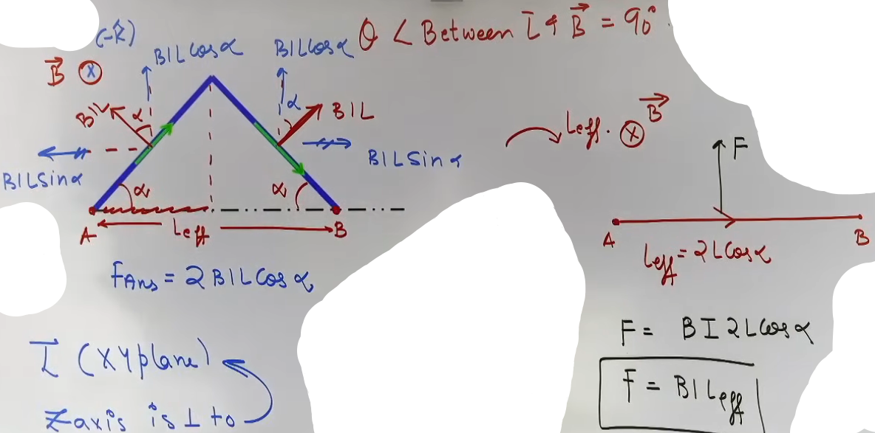
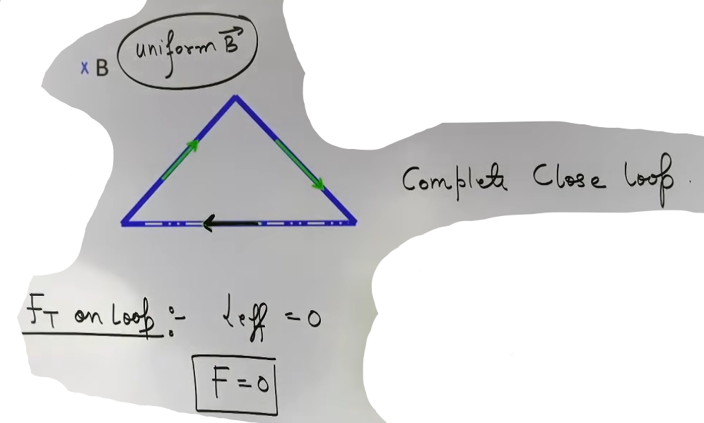
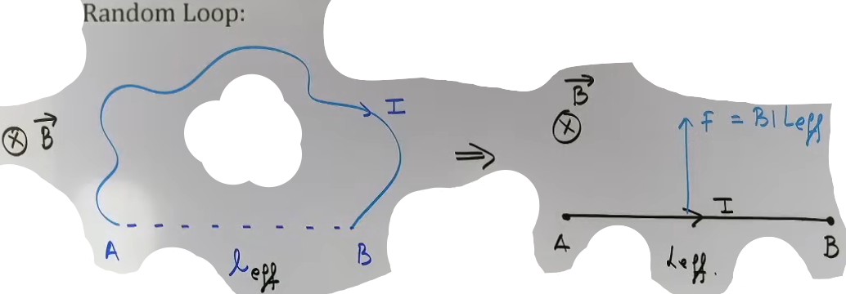
Force Between Parallel Wires
• Mechanism: One wire produces a magnetic field that acts on the second wire, and vice versa.
• Formula (Force per unit length):
F/L = (μ₀/4π)(2I₁I₂/d)
• Nature of Interaction:
• Attraction: When currents in the two wires flow in the same direction.
• Repulsion: When currents flow in opposite directions.
• Teacher’s Remark: Remember that "Like charges repel, but like currents attract".
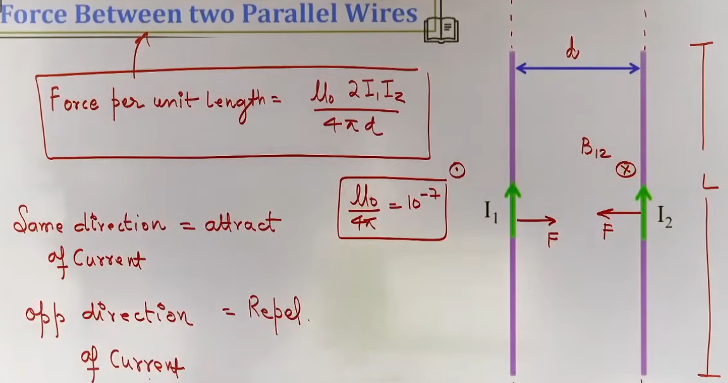
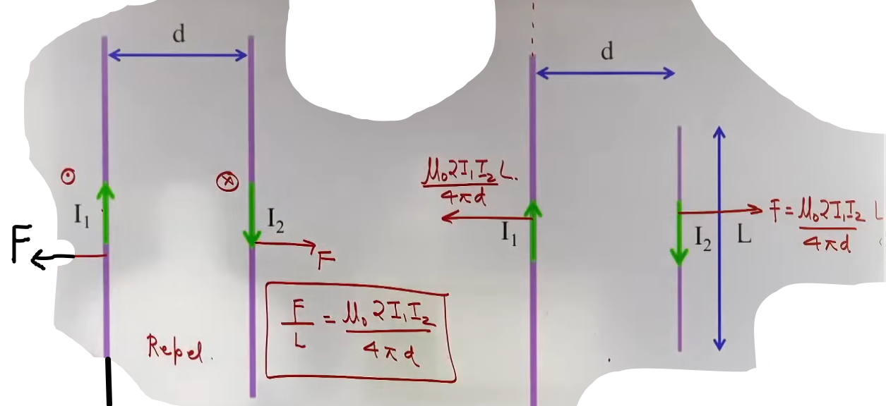
Problem-Solving Framework: Non-Parallel Interactions
Perpendicular Wire
This type of question involves an infinite straight wire and a finite wire placed perpendicular to it. Since the magnetic field B varies with the distance r from the infinite wire, the force cannot be calculated using a single constant or average magnetic field. Instead, consider a small element dr of the perpendicular wire at a distance r, write dF = I₂B(r) dr, and integrate over the length of the finite wire. A common mistake is to use a single “average” value of B instead of accounting for its variation with distance through integration.
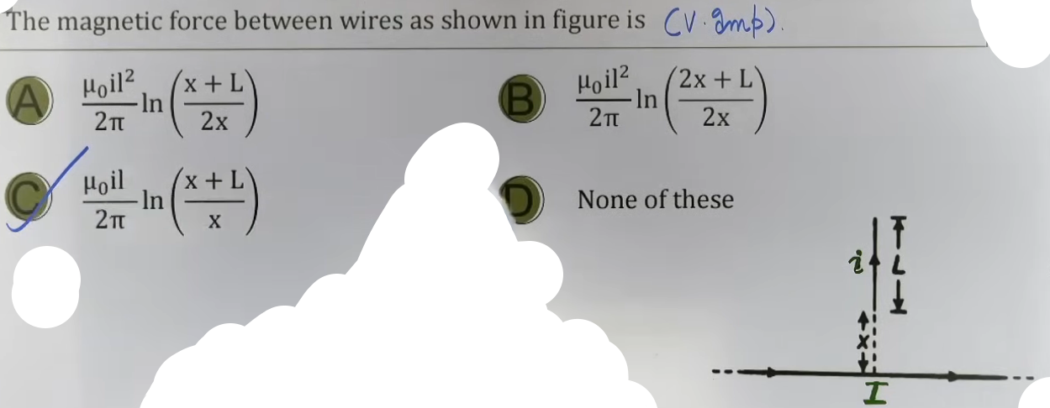
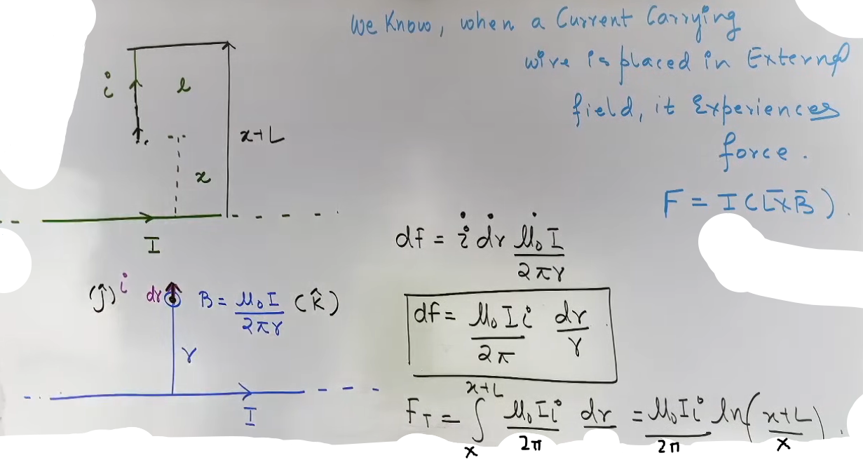
Examples and Applications
• Semicircular Wire in Uniform Field: If a semicircle of radius R carries current I in a field B (perpendicular to the plane), the force is F = B·I·(2R).
• Closed Loop Expansion: While the net force on a loop in a uniform field is zero, it may experience a tendency to expand (tension) if the forces on opposite segments point outward.
• Integration Result (Perpendicular Wire): For a wire of length L starting at distance x from an infinite wire:
F = (μ₀I₁I₂/2π) ln[(x+L)/x]
• Integration Result (Ribbon): For two parallel conductors where one is a ribbon of width b:
F = (μ₀I₁I₂/2πb) ln((a+b)/a)

JEE Advanced Insights
• Variable Magnetic Fields: The L_eff trick fails if the magnetic field is non-uniform. In such cases, you must integrate dF⃗ = I(dL⃗ × B⃗).
• Action-Reaction Pairs: The force wire 1 exerts on wire 2 is equal and opposite to the force wire 2 exerts on wire 1, even in complex geometries.
• Superposition of Forces: When multiple wires are present (e.g., a square loop near an infinite wire), calculate the force on each segment individually and sum them as vectors.

High-Yield Revision Sheet
Must Remember:
• General Force: F⃗ = I(L⃗ × B⃗).
• Effective Length: For uniform B, F⃗ = I(L⃗ₑff × B⃗).
• Parallel Wires: F/L = μ₀I₁I₂/(2πd).
• Closed Loop: Fₙₑₜ = 0 in a uniform field.

Frequently Tested Patterns:
• Force on a Loop near an Infinite Wire: The segments closer to the wire experience a stronger force (1/r dependence), leading to a non-zero net force.
• Integrating for 1/r fields: Be ready to use ∫ (1/r) dr = ln(r) for any problem involving an infinite wire and another conductor.

Last-Minute Revision Points:
• Current is scalar, but I·dL⃗ is a vector.
• If the wire is parallel to B, F = 0.
• In the ribbon problem, the current is divided by width (b) to get current density per unit width.

